1-API

🌐 What Is an API?
# Source: AI Source: Provided by: [Data Path: Persons Table -> ID Column: 1, Name_En Column: Motasem Essam] -> From: [Chatgpt (GPT‑5 Mini)] on [1/19/2026]
API stands for Application Programming Interface.

🧠 In Simple Terms:
# Source: AI Source: Provided by: [Data Path: Persons Table -> ID Column: 1, Name_En Column: Motasem Essam] -> From: [Chatgpt (GPT‑5 Mini)] on [1/19/2026]
API = A set of rules that lets different software programs talk to each other.
It defines how one program can request services or data from another and what responses it can expect.

✅ What APIs Do
# Source: AI Source: Provided by: [Data Path: Persons Table -> ID Column: 1, Name_En Column: Motasem Essam] -> From: [Chatgpt (GPT‑5 Mini)] on [1/19/2026]
- Allow apps, websites, and services to communicate and share data.
- Enable developers to use features of other software without knowing internal details.
- Power integrations between different systems (e.g., your app talking to Google Maps).

🔧 Example
# Source: AI Source: Provided by: [Data Path: Persons Table -> ID Column: 1, Name_En Column: Motasem Essam] -> From: [Chatgpt (GPT‑5 Mini)] on [1/19/2026]
- When you use a weather app, it might call a weather API to get the latest forecast.
- A payment gateway API lets an online store process credit card payments.

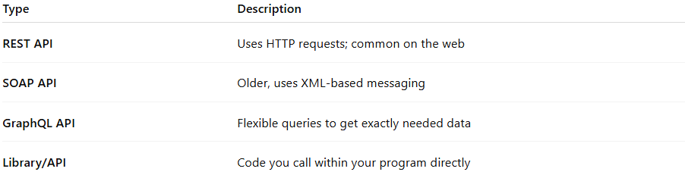

Type | Description
REST API | Uses HTTP requests; common on the web
SOAP API | Older, uses XML-based messaging
GraphQL API | Flexible queries to get exactly needed data
Library/API | Code you call within your program directly

consume an API
# Source: AI Source: Provided by: [Data Path: Persons Table -> ID Column: 1, Name_En Column: Motasem Essam] -> From: [Chatgpt (GPT‑5 Mini)] on [1/19/2026]
When we say “consume an API” in software development, it means that a program or application is using (calling) an API to get data or perform actions provided by another system.

Breaking it down:
- API (Application Programming Interface):
  - A set of rules that allows one software system to interact with another.
  - Example: A weather app can get weather data from a weather service API.
- Consume:
  - To use or request data from the API.
  - Your application “consumes” the API by sending requests and handling the responses.

Example:
Suppose there’s a weather API at https://api.weather.com:
- Request (consuming the API):
GET https://api.weather.com/current?city=Cairo
- Response:
{
"city": "Cairo",
"temperature": "35°C",
"condition": "Sunny"
}
Your app consumed the API by sending a request and using the returned data to display the weather.

Key Points:
- “Consuming an API” does not mean creating the API; it means using it.
- Can be done with different types: REST APIs, SOAP APIs, GraphQL, etc.
- Often involves sending requests (GET, POST, PUT, DELETE) and handling responses (usually JSON or XML).

Summary
# Source: AI Source: Provided by: [Data Path: Persons Table -> ID Column: 1, Name_En Column: Motasem Essam] -> From: [Chatgpt (GPT‑5 Mini)] on [1/19/2026]
An API is like a waiter taking your order (request) to the kitchen (server) and bringing back your food (response). It lets software talk and work together.

2-Web Api

🌐 What Is a Web API?
# Source: AI Source: Provided by: [Data Path: Persons Table -> ID Column: 1, Name_En Column: Motasem Essam] -> From: [Chatgpt (GPT‑5 Mini)] on [1/19/2026]
A Web API is an API that’s accessible over the internet using web protocols, usually HTTP or HTTPS.

🧠 In Simple Terms:
# Source: AI Source: Provided by: [Data Path: Persons Table -> ID Column: 1, Name_En Column: Motasem Essam] -> From: [Chatgpt (GPT‑5 Mini)] on [1/19/2026]
Web API = A way for applications to communicate over the web.
It allows different software systems—like websites, mobile apps, or servers—to exchange data and services through web requests.

✅ Key Features of Web APIs
# Source: AI Source: Provided by: [Data Path: Persons Table -> ID Column: 1, Name_En Column: Motasem Essam] -> From: [Chatgpt (GPT‑5 Mini)] on [1/19/2026]
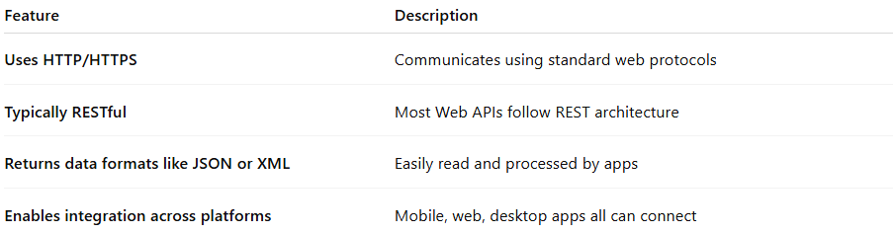

Feature | Description
Uses HTTP/HTTPS | Communicates using standard web protocols
Typically RESTful | Most Web APIs follow REST architecture
Returns data formats like JSON or XML | Easily read and processed by apps
Enables integration across platforms | Mobile, web, desktop apps all can connect

🔰 Common Types of Web APIs:
# Source: AI Source: Provided by: [Data Path: Persons Table -> ID Column: 1, Name_En Column: Motasem Essam] -> From: [Chatgpt (GPT‑5 Mini)] on [1/19/2026]
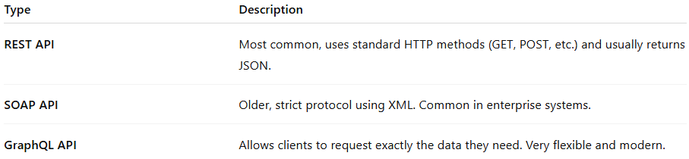

Type | Description
REST API | Most common, uses standard HTTP methods (GET, POST, etc.) and usually returns JSON.
SOAP API | Older, strict protocol using XML. Common in enterprise systems.
GraphQL API | Allows clients to request exactly the data they need. Very flexible and modern.

🧩 Other Types of Web APIs:
# Source: AI Source: Provided by: [Data Path: Persons Table -> ID Column: 1, Name_En Column: Motasem Essam] -> From: [Chatgpt (GPT‑5 Mini)] on [1/19/2026]

Here are more examples that fall under Web APIs:
📦 Open APIs (Public APIs)
- Freely available for anyone to use.
- Example: GitHub API, OpenWeatherMap API, Twitter API
🔒 Private APIs
- Used internally within a company.
- Example: An internal HR system API that employees use.
🤝 Partner APIs
- Shared with specific partners, not the public.
- Example: A payment processor shares APIs with its merchant partners.
🌐 Browser APIs
- Built into web browsers for use in JavaScript.
- Example:
  - fetch() (to make HTTP requests)
  - Geolocation API
  - Web Storage API
  - WebRTC (for real-time communication)

🔧 Example Use Case
# Source: AI Source: Provided by: [Data Path: Persons Table -> ID Column: 1, Name_En Column: Motasem Essam] -> From: [Chatgpt (GPT‑5 Mini)] on [1/19/2026]
A travel app uses a Web API to fetch flight information from an airline.
A website displays Twitter posts by calling the Twitter Web API.
A weather website calls a weather Web API to get real-time forecasts.

🆚 Web API vs Regular API
# Source: AI Source: Provided by: [Data Path: Persons Table -> ID Column: 1, Name_En Column: Motasem Essam] -> From: [Chatgpt (GPT‑5 Mini)] on [1/19/2026]
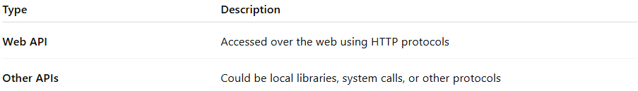

Type | Description
Web API | Accessed over the web using HTTP protocols
Other APIs | Could be local libraries, system calls, or other protocols

APIs for developers Image
# Source: Table Source: Provided by: [Data Path: Persons Table -> ID Column: 1, Name_En Column: Motasem Essam] From: [Data Path: Miscellaneous Folder -> Miscellaneous Database -> Miscellaneous Table -> ID: 26] on [1/19/2026]
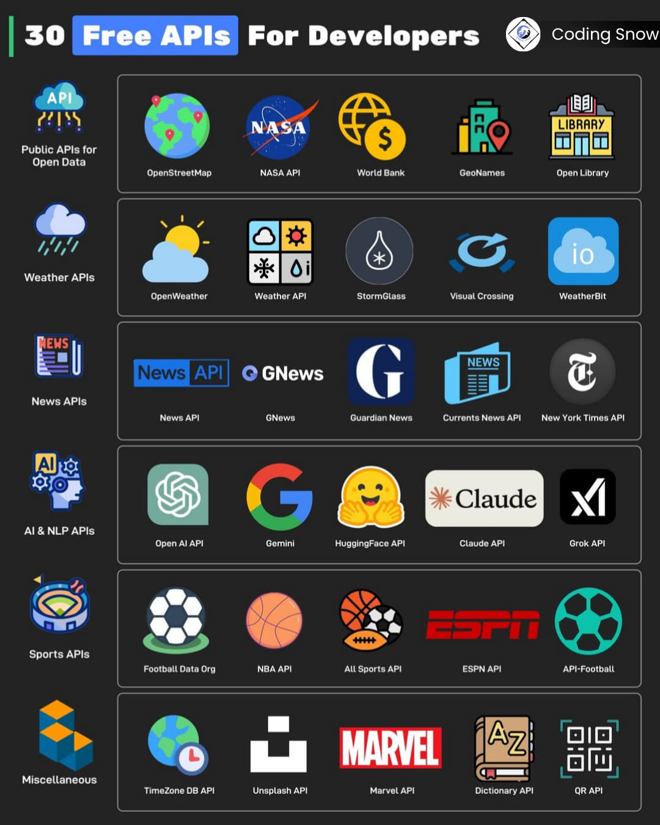

Summary
# Source: AI Source: Provided by: [Data Path: Persons Table -> ID Column: 1, Name_En Column: Motasem Essam] -> From: [Chatgpt (GPT‑5 Mini)] on [1/19/2026]
A Web API is an API accessible via the internet that allows different apps and services to talk and share data using web protocols like HTTP.

